**5. Hosting a static website on Amazon AWS.**

**HARDWARE REQUIREMENTS**: Core I5 Processor, 4 GB RAM, 40GB HDD

**SOFTWARE REQUIREMENTS**: Amazon AWS, S3, VS Code/Eclipse

**Description:**

**AWS (Amazon Web Services)**: a subsidiary of Amazon is a cloud computing platform which provides resources for computation such as EC2 instances, various database and storage facilities as well as networking and content delivery options.

**EC2 (Elastic Compute Cloud):** is a web service which provides computing power in the form of scalable server instances. Multiple EC2 instances are run on the same machine inside Amazon’s computing infrastructure. When an EC2 instance is initiated, a set amount of resources (OS, RAM, Disk Space etc., chosen at the time of initiation) are allotted to the user from the machine it runs on. This allows sharing of resources between multiple users.

**Amazon Simple Storage Service (Amazon S3):** is an object storage service that offers industry-leading scalability, data availability, security, and performance. This means customers of all sizes and industries can use it to store and protect any amount of data for a range of use cases, such as websites, mobile applications, backup and restore, archive, enterprise applications, IoT devices, and big data analytics. Amazon S3 provides easy-to-use management features so you can organize your data and configure finely-tuned access controls to meet your specific business, organizational, and compliance requirements. Amazon S3 is designed for 99.999999999% (11 9's) of durability, and stores data for millions of applications for companies all around the world.

**Steps To configure an S3 bucket for static website hosting:**

* Sign in to the AWS Management Console and open the Amazon S3 console at [https://console.aws.amazon.com/s3/](https://console.aws.amazon.com/s3/#_blank).

**Task 1: Creating a bucket in Amazon S3**

In this task, you will create an S3 bucket and configure it for static website hosting.

1. In the **AWS Management Console**, on the **Services** menu, choose **S3**.

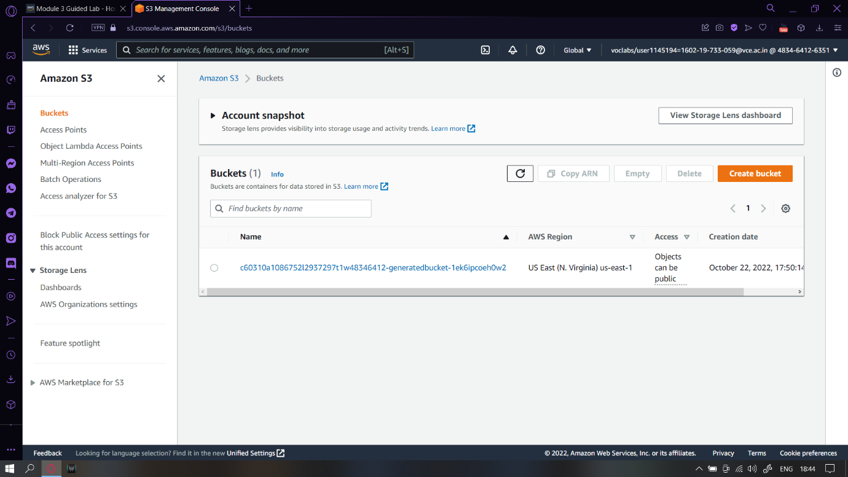

1. Choose **Create bucket**

An S3 bucket name is globally unique, and the namespace is shared by all AWS accounts. After you create a bucket, the name of that bucket cannot be used by another AWS account in any AWS Region unless you delete the bucket.

Thus, for this lab, you will use a bucket name that includes a random number, such as: *website-123*

1. For **Bucket name**, enter: website-<123> (replace <*123*> with a random number)

Public access to buckets is blocked by default. Because the files in your static website will need to be accessible through the internet, you must permit public access.

* + Verify the **AWS Region** is set to **us-east-1** (if it is not, choose the us-east-1 Region)

1. In the **Object Ownership** section, select **ACLs enabled**, then verify **Bucket owner preferred** is selected.

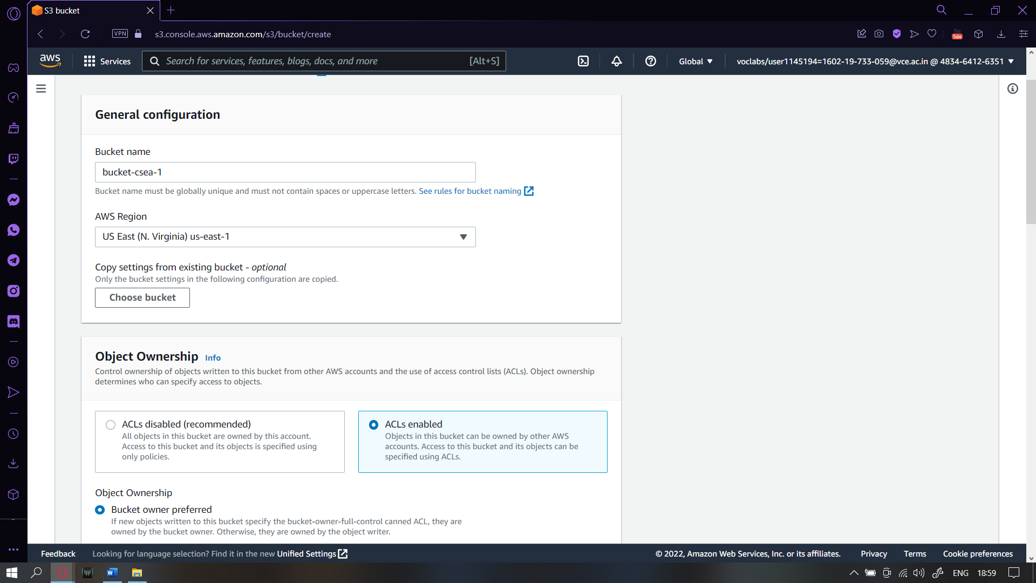

1. Clear **Block all public access**, then select the box that states **I acknowledge that the current settings may result in this bucket and the objects within becoming public**.

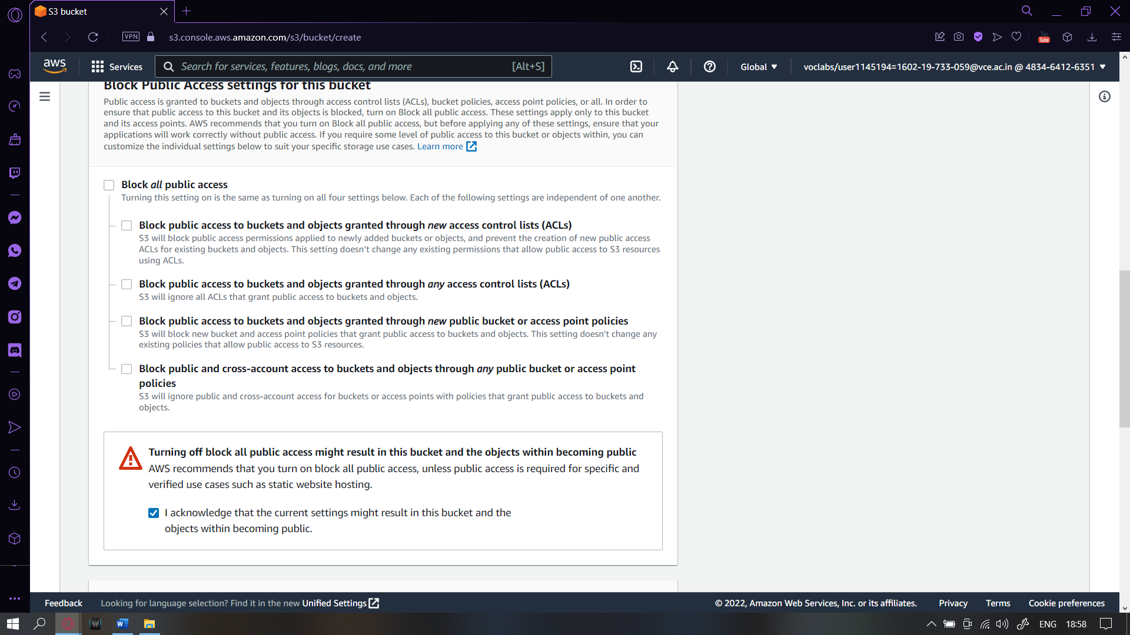

1. Choose **Create bucket**.

You can use tags to add additional information to a bucket, such as a project code, cost center, or owner.

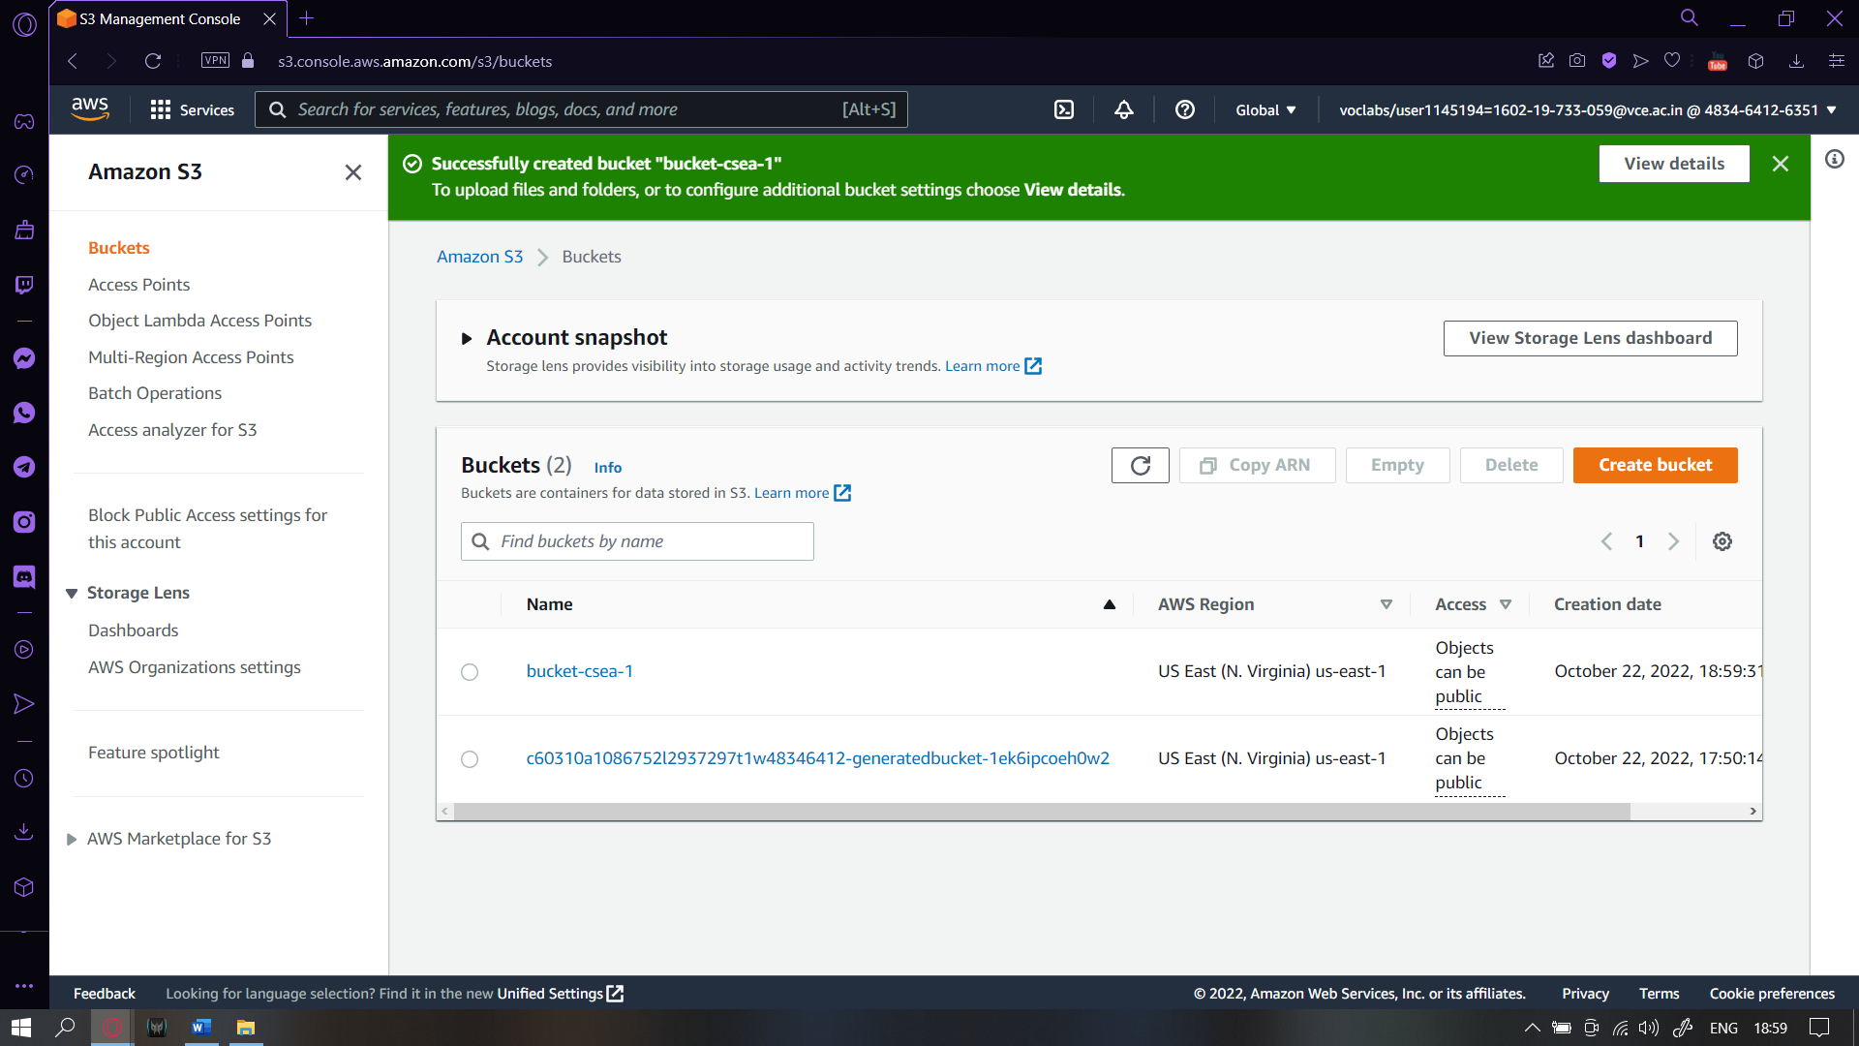

1. Choose the name of your new bucket.
2. Choose the **Properties** tab.

1. Scroll to the **Tags** panel.
2. Choose **Edit** then **Add tag** and enter:

* **Key:** Department
* **Value:** Marketing

1. Choose **Save changes** to save the tag.

Next, you will configure the bucket for static website hosting.

1. Stay in the **Properties** console.
2. Scroll to the **Static website hosting** panel.
3. Choose **Edit**
4. Configure the following settings:
   * **Static web hosting:** Enable
   * **Hosting type:** Host a static website
   * **Index document:** index.html
     + **Note**: You must enter this value, even though it is already displayed.
   * **Error document:** error.html

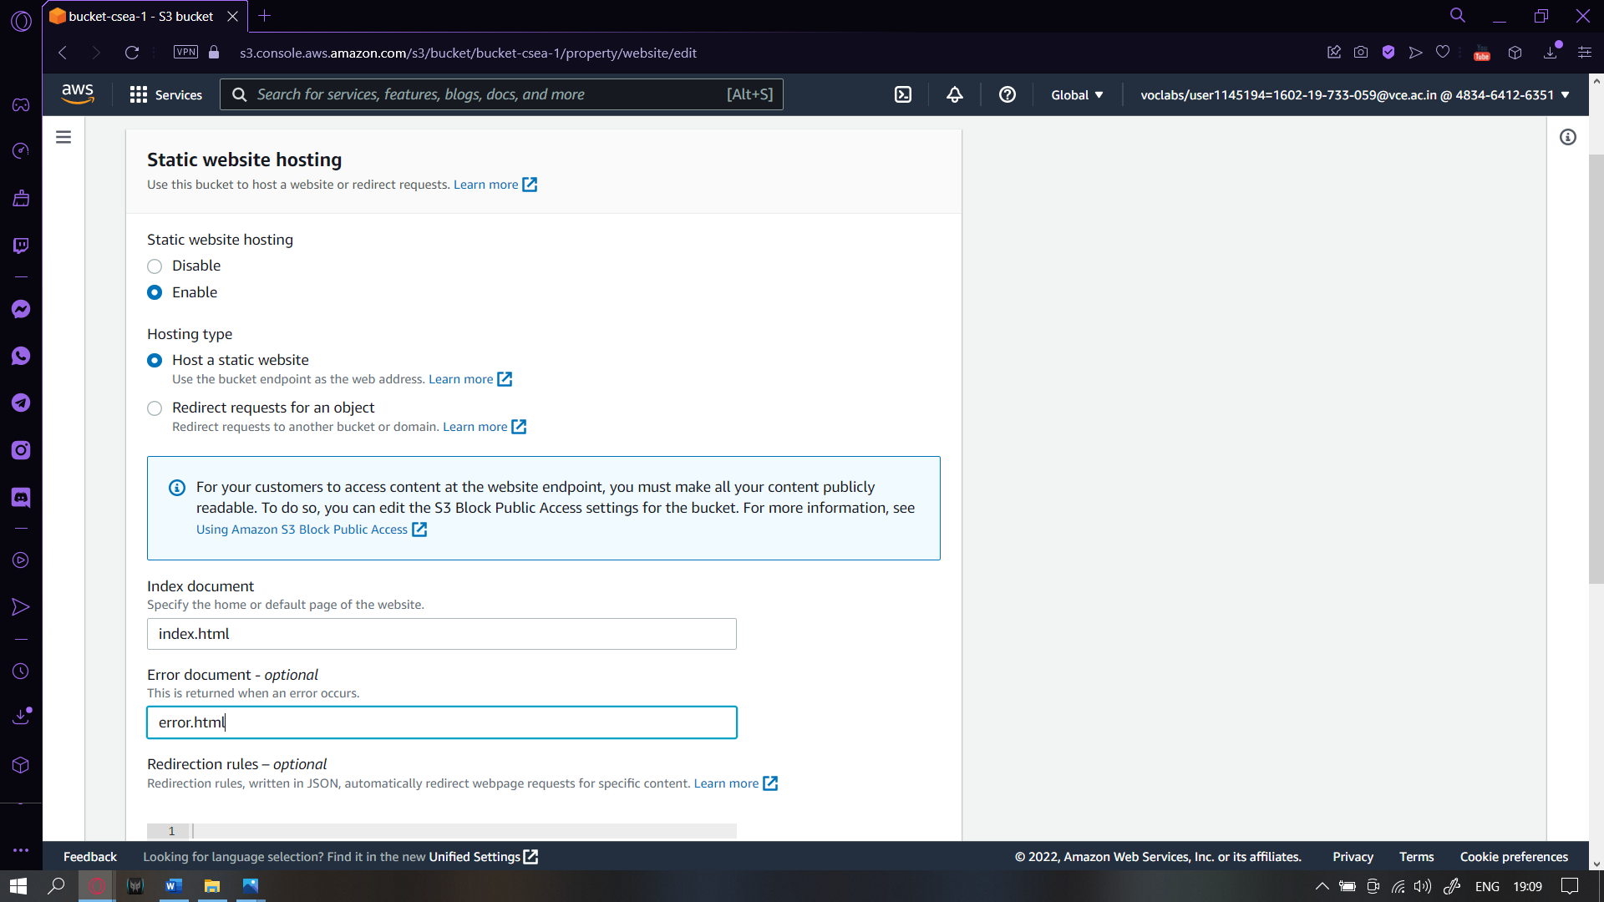

1. Choose **Save changes**
2. In the **Static website hosting** panel, choose the link under **Bucket website endpoint**.

You will receive a *403 Forbidden* message because the bucket permissions have not been configured yet. Keep this tab open in your web browser so that you can return to it later.Your bucket has now been configured to host a static website.

**Task 2: Uploading content to your bucket**

In this task, you will upload the files that will serve as your static website to the bucket.

1. Right-click each of these links and download the files to your computer:

Ensure that each file keeps the same file name, including the extension.

* + [index.html](https://labs.vocareum.com/web/1145194/1086752.0/ASNLIB/public/scripts/index.html)
  + [script.js](https://labs.vocareum.com/web/1145194/1086752.0/ASNLIB/public/scripts/script.js)
  + [style.css](https://labs.vocareum.com/web/1145194/1086752.0/ASNLIB/public/scripts/style.css)

1. Return to the Amazon S3 console and in the website-<123> bucket you created earlier, choose the **Objects** tab.

1. Choose **Upload**

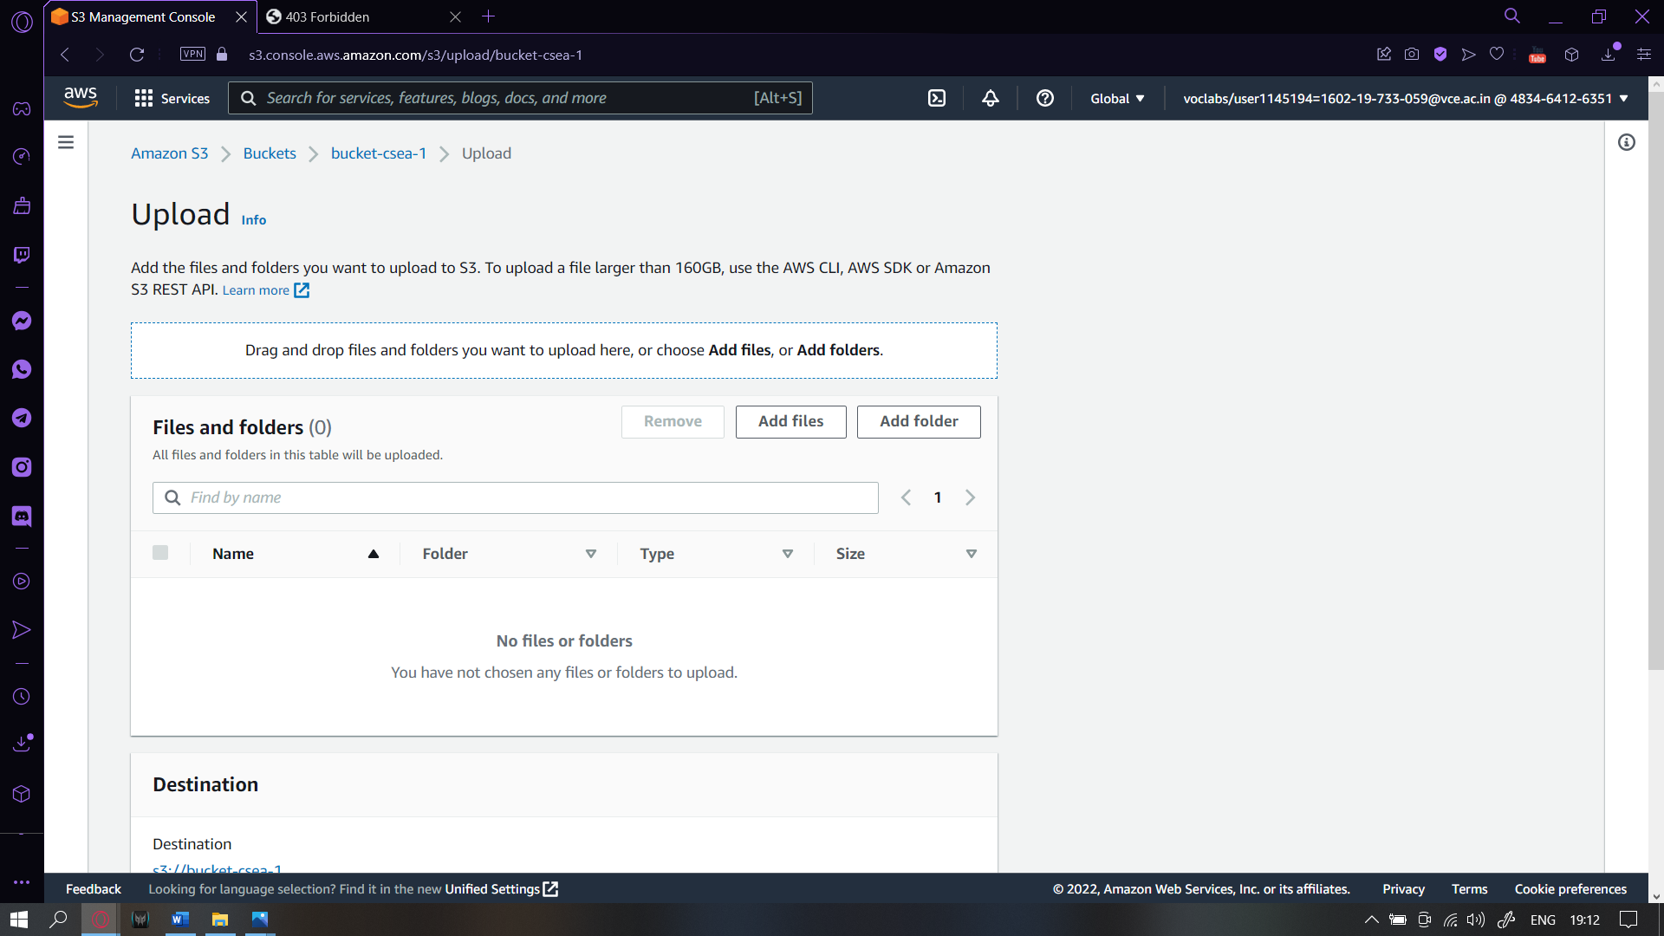

1. Choose **Add files**
2. Locate and select the three files that you downloaded.
3. If prompted, choose I acknowledge that existing objects with the same name will be overwritten.
4. Choose **Upload**

Your files are uploaded to the bucket.

* + Choose **Close**

**Task 3: Enabling access to the objects**

Objects that are stored in Amazon S3 are private by default. This ensures that your organization's data remains secure.

In this task, you will make the uploaded objects publicly accessible.

First, confirm that the objects are currently private.

1. Return to the browser tab that showed the *403 Forbidden* message.
2. Refresh the webpage.

If you accidentally closed this tab, go to the **Properties** tab, and in the **Static website hosting** panel choose the **Endpoint** link again.

You should still see a *403 Forbidden* message.

*Analysis*: This response is expected! This message indicates that your static website is being hosted by Amazon S3, but that the content is private.

You can make Amazon S3 objects public through two different ways:

* + To make either a whole bucket public, or a specific directory in a bucket public, use a *bucket policy*.
  + To make individual objects in a bucket public, use an *access control list (ACL)*.

It is normally safer to make *individual objects* public because this avoids accidentally making other objects public. However, if you know that the entire bucket contains no sensitive information, you can use a *bucket policy*.

You will now configure the individual objects to be publicly accessible.

1. Return to the web browser tab with the Amazon S3 console (but do not close the website tab).
2. Select all three objects.
3. In the **Actions** menu, choose **Make public via ACL**.

A list of the three objects is displayed.

1. Choose **Make public**

Your static website is now publicly accessible.

1. Return to the web browser tab that has the *403 Forbidden* message.
2. Refresh the webpage.

You should now see the static website that is being hosted by Amazon S3.

## Task 4: Updating the website

You can change the website by editing the HTML file and uploading it again to the S3 bucket.

Amazon S3 is an object storage service, so you must upload the whole file. This action replaces the existing object in your bucket. You cannot edit the contents of an object—instead, the whole object must be replaced.

1. On your computer, load the **index.html** file into a text editor (for example, Notepad or TextEdit).
2. Find the text **Served from Amazon S3** and replace it with Created by <YOUR-NAME>, substituting your name for <YOUR-NAME> (for example, Created by Jane).
3. Save the file.
4. Return to the Amazon S3 console and upload the **index.html** file that you just edited.

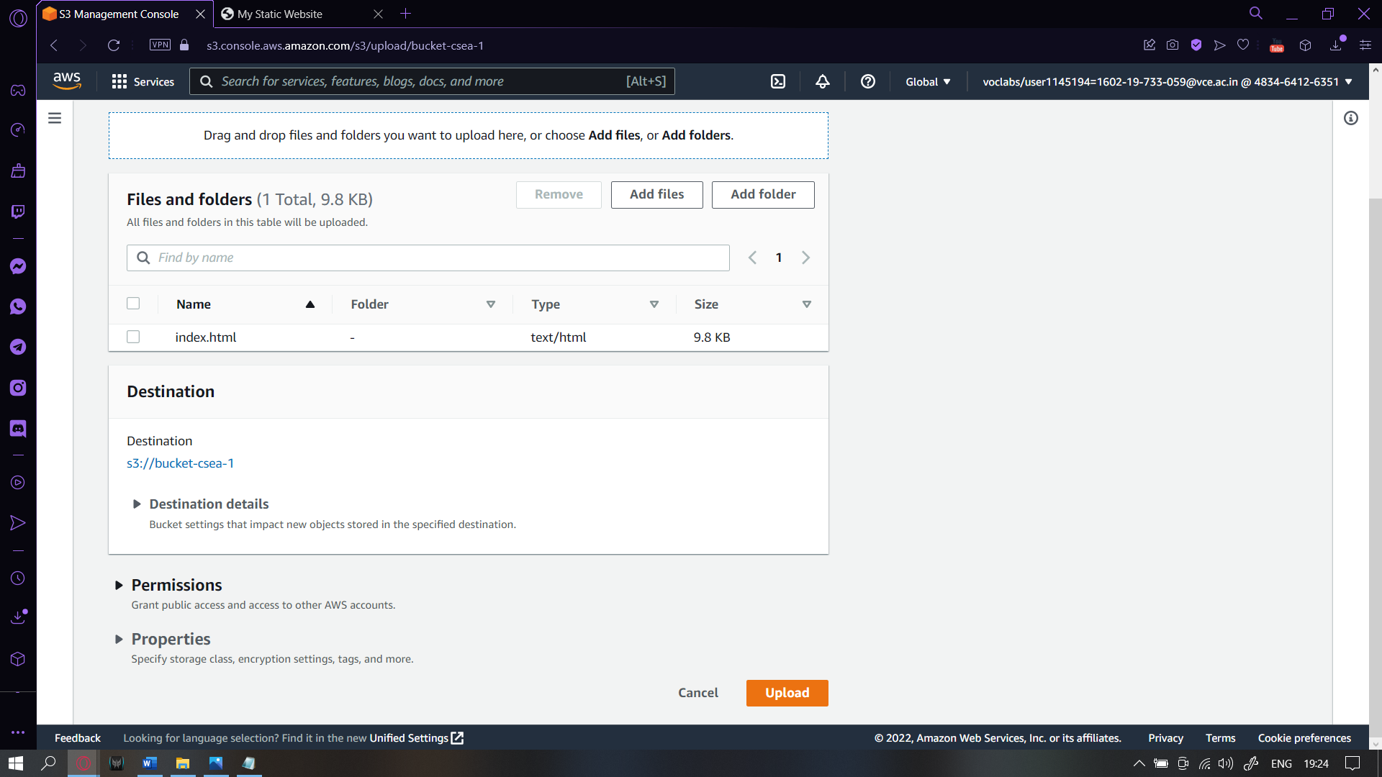

1. Select **index.html** and use the **Actions** menu to choose the **Make public via ACL** option again.
2. Return to the web browser tab with the static website and refresh the page.

Your name should now be on the page.

